

**MODEL INSTITUTE OF ENGINEERING & TECHNOLOGY, JAMMU**

**Business Process Automation with RPA (COM-212)**

**Submitted By: Faculty Incharge:**

Simriti Kak Asst Prof . Vani Malagar

2022a1r004

A2 2nd sem

**CONTENT**

* Abstract…………………………………………………………….. 3
* Introduction………………………………………………………… 4
* Problem Statement…………………………………………………. 5
* Objectives…………………………………………………………...5
* Methodology……………………………………………………….. 6
* Bot Workflow, Sequence, Outputs…………………………………. 7-18
* Conclusion…………………………………………………………. 18
* Future Enhancements………………………………………………. 19
* References…………………………………………………………...20

**.**

**ABSTRACT**

The "Savvy Shopper Bot" is a user-friendly bot designed to assist online shoppers (Students) in finding the most affordable product between Amazon and Flipkart. By taking input from the user, the bot compare prices on both platforms, ensuring that users make informed decisions while making purchases. The bot provides the final result in a convenient message box, displaying the most cost-effective option. This project aims to simplify the online shopping experience by saving users' time and money, enabling them to make well-informed decisions effortlessly.

**INTRODUCTION**

Welcome to the world of online shopping made easier with the Savvy Shopper Bot! With the rise of e-commerce giants like Amazon and Flipkart, finding the best deal can be a daunting task. The abundance of options and fluctuating prices often leave consumers feeling overwhelmed and unsure about where to find the most affordable products. That's where the Savvy Shopper Bot comes in.

Designed to simplify your online shopping experience, the Savvy Shopper Bot is a user-friendly virtual assistant that takes the hassle out of comparing prices between Amazon and Flipkart. Gone are the days of endlessly scrolling through product listings and juggling multiple browser tabs. Our intelligent bot is here to do the heavy lifting for you.

Using advanced algorithms and cutting-edge web scraping technology, the Savvy Shopper Bot swiftly retrieves and analyzes pricing data from both Amazon and Flipkart. By considering factors such as product price, shipping fees, the bot provides you with a comprehensive overview of the most cost-effective options available.

No more second-guessing or spending hours manually researching prices. The Savvy Shopper Bot does the legwork for you, delivering the final results in a convenient message box.

Our mission is to save you time and money while ensuring you get the best value for your hard-earned money . Whether you're searching for electronics, clothing, household items, or any other product, the Savvy Shopper Bot has got you covered.

Get ready to embark on a seamless and cost-effective online shopping journey with the Savvy Shopper Bot. Say goodbye to the stress of comparing prices and say hello to a world of convenience, savings, and informed decision-making. Let's start finding you the best deals across Amazon and Flipkart – all at the click of a button.

**PROBLEM STATEMENT**

The problem statement is to develop a solution that automates price comparison between Amazon and Flipkart, enabling users to easily find the most affordable product and make informed purchasing decisions.

**OBJECTIVES**

1.Provide a Convenient Shopping Experience: The primary objective of the Savvy ShopperBot is to simplify the online shopping process for users. By automatically comparing prices between Amazon and Flipkart, the bot aims to eliminate the need for users to manually browse and switch between multiple platforms, saving them time and effort.

2.Find the Most Affordable Option: The bot's main objective is to identify the most cost-effective product by considering various factors such as price, discounts, shipping fees, andratings. By presenting users with the best available option, the bot helps users make informed purchasing decisions that align with their budgetary constraints.

3.Enhance User Savings: By providing users with real-time price comparisons, the Savvy Shopper Bot aims to help users save money. Users can take advantage of the bot's insights to identify discounted products, exclusive offers, and the best value for their desired items.

**METHODOLOGY**

1. Data Collection: The methodology involves utilizing data scraping technique to collect product data, including prices, , ratings from both Amazon and Flipkart platforms.

2. Feature Selection: Relevant features such as price, discounts, shipping fees, and ratings are selected for comparison.

3. User Interaction and Input Handling: The bot is designed to interact with users, allowing them to input their desired product details. The system validates inputs, and ensures a smooth user experience throughout the interaction.

4. Result Presentation: The final comparison results are presented to the user in a clear and concise manner. A message box or user interface displays the most cost-effective option, along with relevant product details, allowing users to make informed decisions effortlessly.

5. Testing and Refinement: The methodology includes rigorous testing to ensure the accuracy and reliability of the bot. User feedback and performance metrics are collected to refine the algorithm and improve the overall user experience.

The methodology outlined above provides a systematic approach to automate the process of comparing product prices between Amazon and Flipkart, enabling users to find the most affordable option and make well-informed purchasing decisions.

**BOT WORKFLOW**

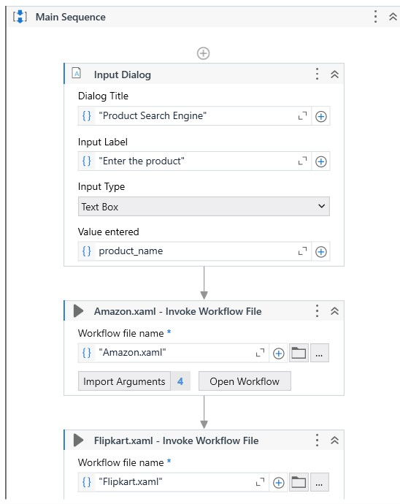

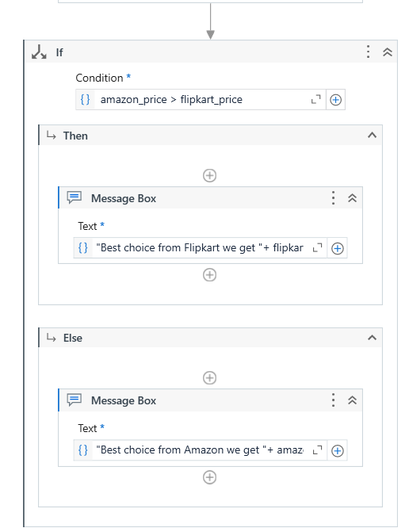

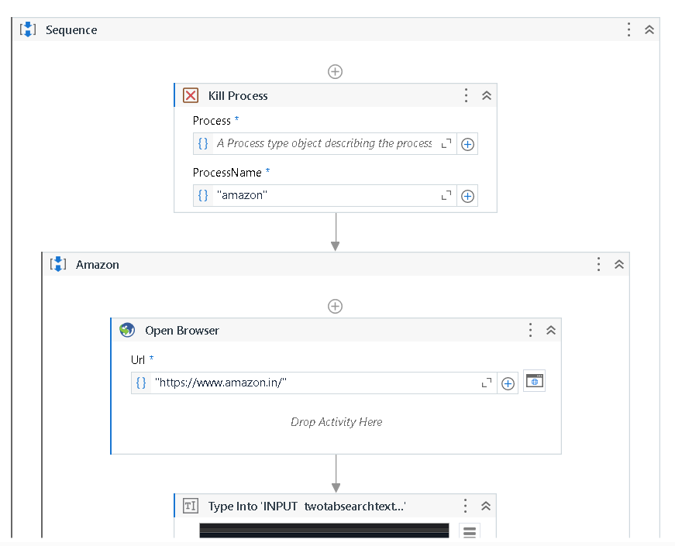

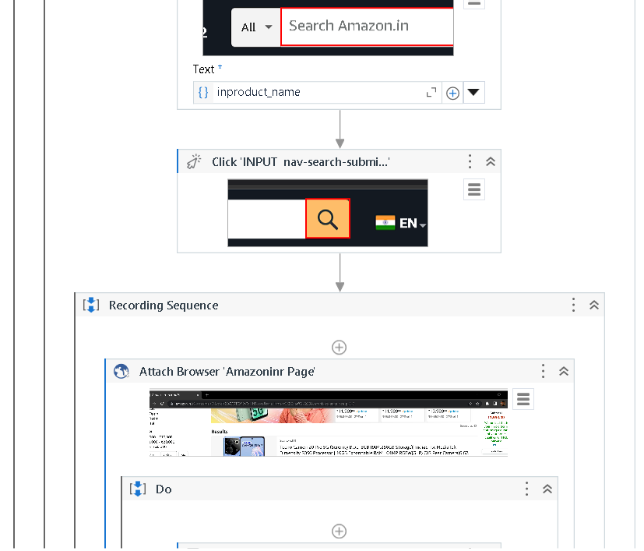

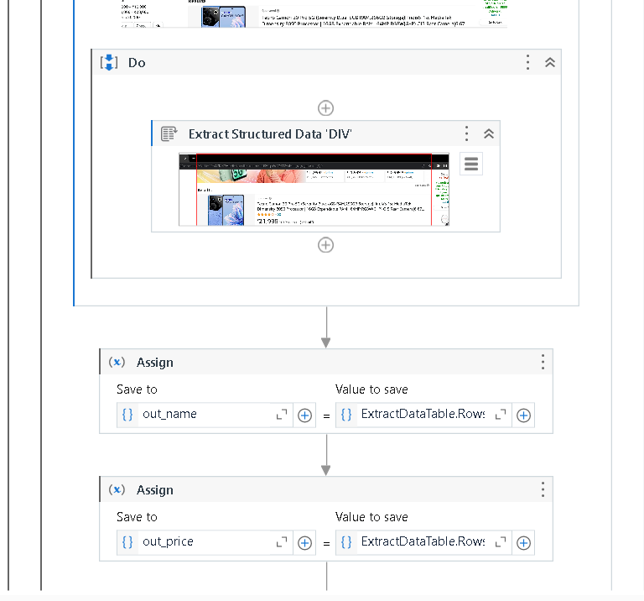

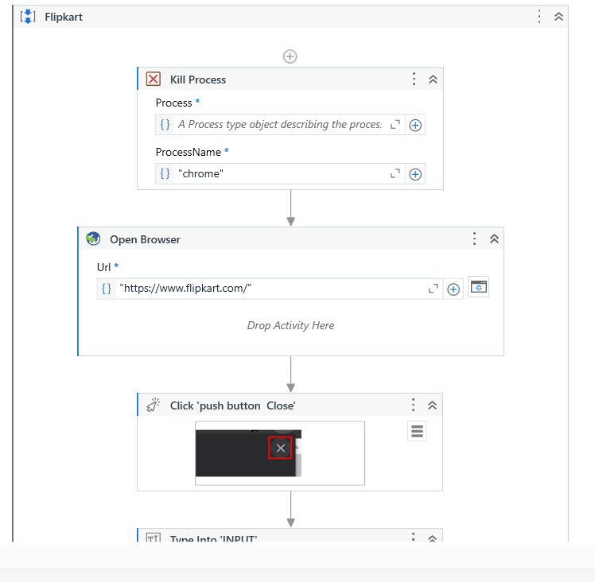

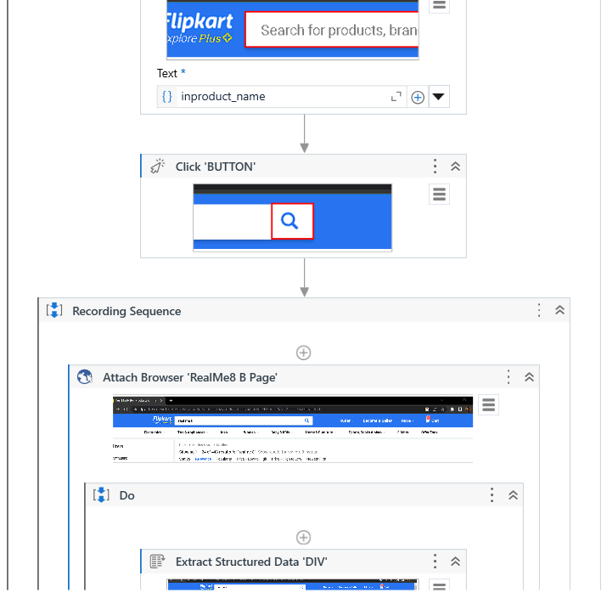

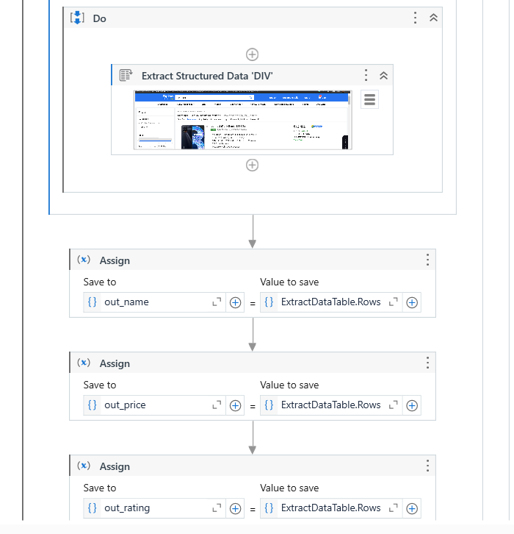

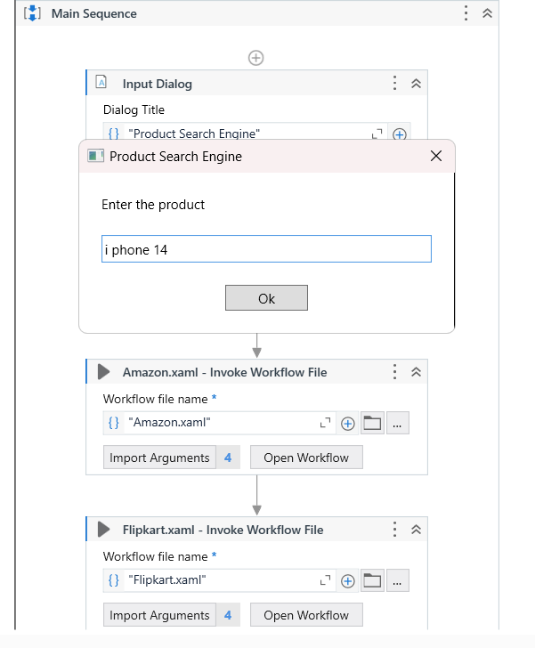

**Outputs**

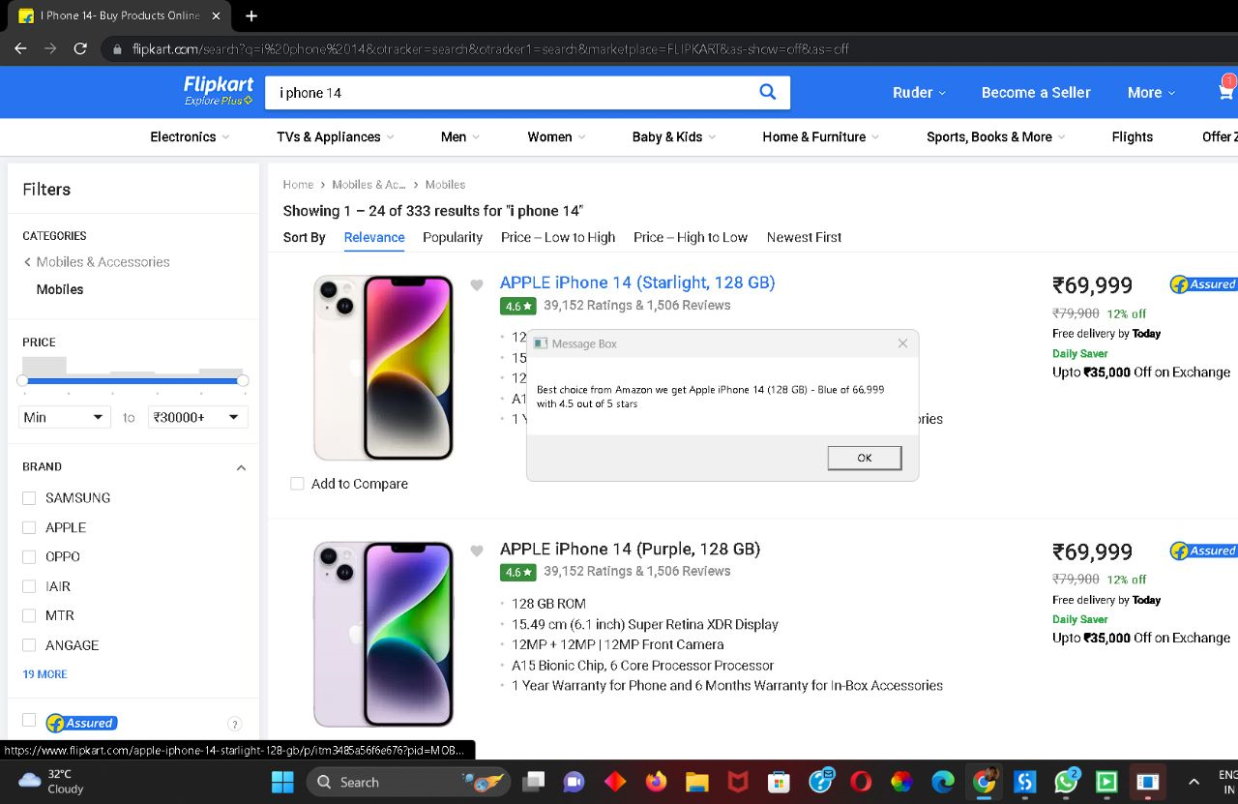

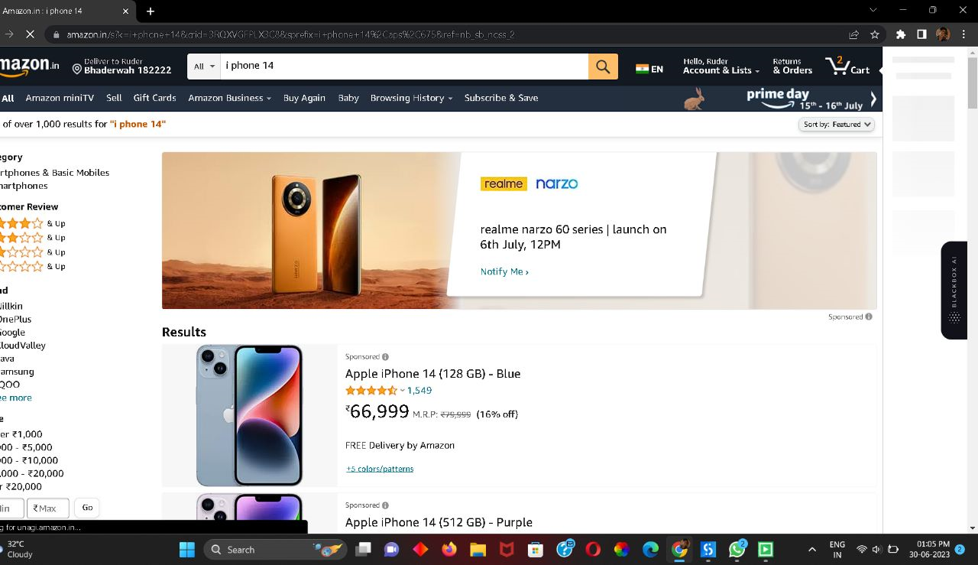

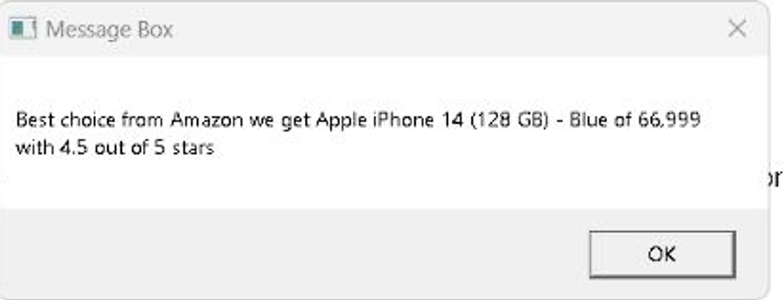

**CONCLUSION**

In conclusion, the Savvy Shopper Bot offers a transformative solution to the challenges faced by online shoppers on Amazon and Flipkart. By leveraging intelligent algorithms and advanced web scraping techniques, the bot efficiently compares product prices, discounts, and other essential factors between the two platforms, enabling users to make well-informed purchasing decisions. With a user-friendly interface and convenient message box output, the bot streamlines the online shopping experience, saving users valuable time and money. By empowering users with real-time price comparisons and reliable information, the Savvy Shopper Bot enhances user satisfaction and confidence in their shopping choices. This innovative virtual assistant epitomizes the future of online shopping, where technology simplifies complex tasks, transforming the way users shop and helping them discover the most cost-effective options effortlessly.

**FUTURE ENHANCEMENTS**

Multi-platform Support: Currently, the Savvy Shopper Bot compares prices between Amazon and Flipkart. In the future, the bot can be expanded to include additional e-commerce platforms, allowing users to compare prices across a broader range of online marketplaces.

Real-time Price Tracking: Implementing real-time price tracking functionality would enable users to monitor price fluctuations over time. This feature would provide users with insights into price trends, allowing them to make informed decisions on when to make a purchase to maximize savings.

Personalized Recommendations: Enhancing the bot with personalized recommendation capabilities would take into account user preferences, purchase history, and ratings to suggest products that align with their individual preferences. This would provide a tailored shopping experience and increase user satisfaction.

Integration with User Accounts: Integrating the Savvy Shopper Bot with user accounts on Amazon and Flipkart would enable personalized features such as accessing wishlists, tracking order history, and receiving personalized discounts or offers. This integrationwould enhance user convenience and create a seamless shopping experience.

**REFERENCES**

[1] J. G. Enr´ıquez, A. Jime´nez-Ram´ırez, F. J. Dom´ınguez-Mayo and J. A. Garc´ıa-Garc´ıa “Robotic Process Automation: A Scientific and Industrial Systematic Mapping Study,” in IEEE Access, vol. 8, pp. 39113-39129, 2020, doi: 10.1109/ACCESS.2020.2974934.

[2] A. Leshob, A. Bourgouin and L. Renard, “Towards a Process Analysis Approach to Adopt Robotic Process Automation,” 2018 IEEE 15th International Conference on e-Business Engineering (ICEBE), Xi’an, China, 2018, pp. 46-53, doi: 10.1109/ICEBE.2018.00018.

[3] Naveen Joshi, (2019). Here’s what RPA means to the education sector

[4] Neil Kinson, (2018). Automate the Education Sector with Education Management Software Solutions, How Automation will impact Education.

[5] Kuppusamy, Palanivel Joseph K, Suresh. (2020). Robotic Process Automation to Smart Education. 3775.

[6] Alcatel-Lucent, (2019). Why Digital Transformation for Education?   
[7] Karl Utermohlen, (2019). Four Ways Machine Learning Is Shaping the Future of Education

[8] Ibtehal Talal Nafea, (2018). Machine Learning in Educational Technology, 176-182.

[9] Savaram Ravindra, (2018). Role of IoT in Education

[10] UiPath Documentation - Excel Package: Documentation specifically focused on the Excel package within UiPath, explaining activities for interacting with Excel files, reading and writing data, and modifying cells.